

September 2026

Summary

Contents
1 Introduction 1
1.1 The MOT Test 1
1.2 The vehicle data landscape of the United Kingdom 1
1.2.1 Driving Vehicle Licence Authority (DVLA) 2
1.2.2 Driving Vehicle Safety Authority (DVSA) 2
1.2.3 The Department for Transport 2
1.2.4 Driving Vehicle Agency Northern Ireland (DVA NI) 2
1.3 Vehicle Registration Marks (VRM)s 2
1.3.1 Personalised number plates 3
1.4 Geography of Vehicle Data 3
1.4.1 Limitations of the Postcode Area as a unit of analysis. 4
2 Methodology 5
2.1 Data Sources 5
2.1.1 DVSA Bulk MOT API 6
2.1.2 Anonymised MOT Data 6
2.1.3 DVLA Vehicle Enquiry Service (VES) API 6
2.2 Linking the Anonymised MOT to the Bulk MOT data 6
2.3 Linking the VES API to the Bulk MOT data 6
2.4 Make and Model Cleaning 6
2.5 VRM Analysis 6
2.6 Annual Milage Calculation 6
3 Key Concepts 7
3.1 MOT test classes and vehicle types 7
3.2 Differences between type approval, DfT stats and MOT stats 8
3.3 The ‘Lifecycle’ of a vehicle 10
3.3.1 Newly built vehicles 10
3.3.2 Vehicles imported into the UK 10
3.3.3 The first MOT test 10
3.3.4 Subsequent MOT tests 11
3.3.5 Statutory Off Road Notice (SORN)ed vehicles 11
3.3.6 End of life vehicles 11
4 Data Products 12
4.1 Full Data Set 12
4.1.1 Licensing, Access, and conditions of use 12
4.1.2 Annulised Table 12
4.2 Malcolm Table 13
4.2.1 Variable Level Descriptions 13
4.3 Anonymised Vehicle Level Data 14
4.3.1 Licensing, Access, and conditions of use 14
4.4 Aggregated Data 14
4.4.1 Licensing, Access, and conditions of use 14
5 Example Analysis 15
6 References 16
7 Appendices 17

List of Tables
Table 1: MOT Test Classes and requirements, from GOV.UK 5

List of Figures
Figure 1: A map of the United Kingdom with Local Authority Districts overlain over Postcode Areas 3

List of Abbreviations and Acronyms

DVLA
DVSA
OGL
MOT Test
DfT

List of Appendices
Appendix 1 Data Dictionary for Anonymized Vehicle Level Data 8
Appendix 2 9

Introduction

The MOT Test

During covid there were changes to the way MOT tests were managed. this differed in different parts of the UK

Northern Ireland. Shortly before covid Jan 2020 large number of MOT test exemptions were issued because of damage to MOT test centre equipment

https://www.bbc.co.uk/news/uk-northern-ireland-56181257

The vehicle data landscape of the United Kingdom

Administrative data collected by DfT “family” of agencies

Administrative data released by DfT “family of agencies”

Other Govt sources

ONS census

DfT annual travel statistics

NTS

Driving Vehicle Licence Authority (DVLA)

Driving Vehicle Safety Authority (DVSA)

The Department for Transport

Driving Vehicle Agency Northern Ireland (DVA NI)

Vehicle Registration Marks (VRM)s

A VRM is more commonly called a registration number (even though it ususally contains letters and numbers) . In Other Countries it may be called a licence plate.

The rules about how they must be displayed on vehicles is here https://www.gov.uk/displaying-number-plates

The format of UK VRMS is available here https://en.wikipedia.org/wiki/Vehicle_registration_plates_of_the_United_Kingdom

Personalised number plates

Geography of Vehicle Data
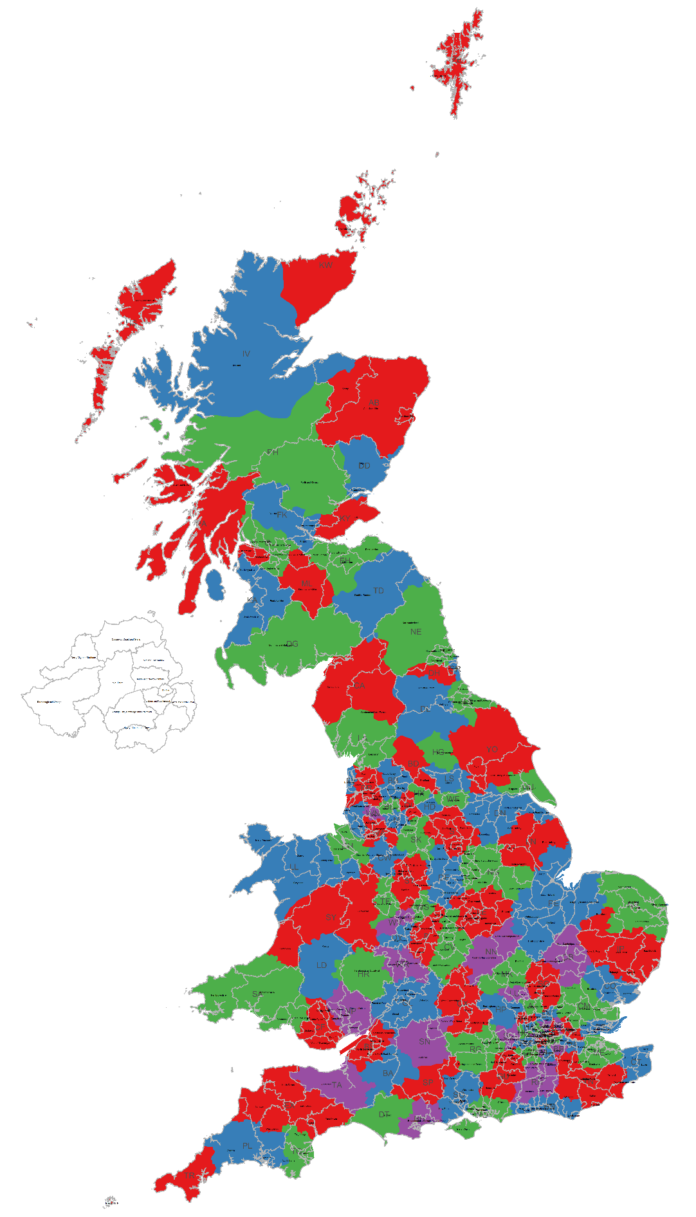
Figure 1: A map of the United Kingdom with Local Authority Districts overlain over Postcode Areas

Basic information: Postcodes history and boundaries
Postcodes were originally applied in London in the 1860s with compass based ditricts N, S, E ,W. Then expanded to the provincial cities with a single letter, e.g. B, G, L . The current system was developed in the 1970s. (https://www.postalmuseum.org/collections/postcodes/#:~:text=The%20history%20of%20postcodes%20can%20be%20traced,the%20circulation%20of%20mail%2C%20particularly%20local%20letters.)
Postcodes and the spatial areas they cover are designed for ‘the sole purpose of facilitating efficient mechanised mail sorting and delivery’.

Other spatial units of data that we use or should be aware of.
Census data: We use census data. Census data is nested as follows. OA inside LSOA inside MSOA. OA and LSOA boundaries have been designed in a way that there is some similarity of socio-demographic characteristics amongst the populations in each area.
Administrative data. We typically do not use the smallest unit – the ward. Wards nest into Local Authority Districts. Local Authority Districts nest into Counties in some cases, and into Regions.
Census geographies also nest into Local Authority Districts which gives a useful connection between census and administrative geographies.
Travel to work areas TTWA: Are determined from census LSOA and MSOA travel to work flows. There are 228 in the UK 149 TTWAs in England, 45 in Scotland, 18 in Wales, 10 in Northern Ireland and 6 cross-border TTWAs.
https://www.ons.gov.uk/employmentandlabourmarket/peopleinwork/employmentandemployeetypes/articles/traveltoworkareaanalysisingreatbritain/2016#:~:text=Travel%20to%20work%20areas%20(TTWAs)%20are%20self%2Dcontained,in%20Northern%20Ireland%20*%206%20cross%2Dborder%20TTWAs
To keep this brief I’ve not talked about Health Geographies or parliamentary constituencies.

Limitations of the Postcode Area as a unit of analysis.
Summary:
- PCA are very large
- Do not align with administrative / census geographies.
- Combine rural and urban , and various socio economic groups
- Within area variation of car use may exceed between area variation.
- Aggregation smoothing effect.
- We have reasonable certainty about the numbers, but, less certainty about whether they are helpful.

Issues of linking Postcode areas to administrative areas.
There is no alignment between postcodes and administrative boundaries. This means that lookups are “best fit”
“Linking postal geographies to other geographic units is far from straightforward though, as postcode boundaries mostly do not align with other geographic boundaries. If a postcode boundary (reflecting all the addresses with that postcode) straddles a ward (or other) boundary, you have to decide which ward to allocate any data for that postcode to. Our postcode directories take the grid reference of the postcode centroid and match this up to digital administrative boundaries. However, some addresses (and therefore data) will still inevitably be allocated to the "other" area.” https://www.ons.gov.uk/methodology/geography/ukgeographies/postalgeography#:~:text=Linking%20postal%20geographies%20to%20other,to%20the%20%22other%22%20area

Issues of aggregation

The Core Difference: Modifiable Areal Unit Problem (MAUP)
The primary difference when conducting spatial analysis in highly aggregated areas is the emergence of the Modifiable Areal Unit Problem (MAUP). The MAUP has two main components:
- Scale Effect: (or smoothing effect) Results of the analysis change depending on the size of the aggregation units used (e.g., the mean, and median population density or mean annual mileage at the LSOA level yields different results than at the Postcode Area level ).
- Zoning/Shape Effect: Different ways of grouping the same set of small units into areas of similar size can also produce different results, as the original zonal configuration is arbitrary.
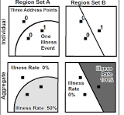
Source: https://en.wikipedia.org/wiki/Modifiable_areal_unit_problem
The zoning effect might be exacerbated because postcode boundaries have been designed for efficient mail logistics and not to represent geodemographic differences. (see this for more https://mgimond.github.io/Spatial/pitfalls-to-avoid.html#ref-Unwin1 ).

“MAUP is not just a technical nuisance–it challenges the validity of spatial inference when based on aggregated data.”
This means that patterns we are seeing in data at PCA level may not be valid.

An example is given here https://mgimond.github.io/Spatial/pitfalls-to-avoid.html#ref-Unwin1 where at the individual level the correlation between 2 variables is negligible, but following aggregation to arbitrary polygons a strong correlation appears.

Consequences of Aggregation in Spatial Analysis
- Loss of Information: Aggregation generally destroys fine-grained local information and detail, making it difficult to detect local-scale patterns or "hot spots".
- Introduction of Bias and Error: The process introduces aggregation error and bias to new estimates because they are derived from summarized rather than original, individual-level data.
- The Ecological Fallacy: Aggregated data can lead to the "ecological fallacy," an error in reasoning that occurs when conclusions about individuals are mistakenly drawn from data analyzed at the group or aggregate level. The relationships observed at the aggregate level may be different, or even the reverse, of those at the individual level.
- Unstable Rate Estimates: Data in small areas or with low population sizes can have large standard errors and fluctuating estimates. Aggregation is sometimes used to stabilize these rates, but this smoothing comes at the cost of altering reliable estimates in other areas.

Illustration of smoothing using PCA resolution car use data

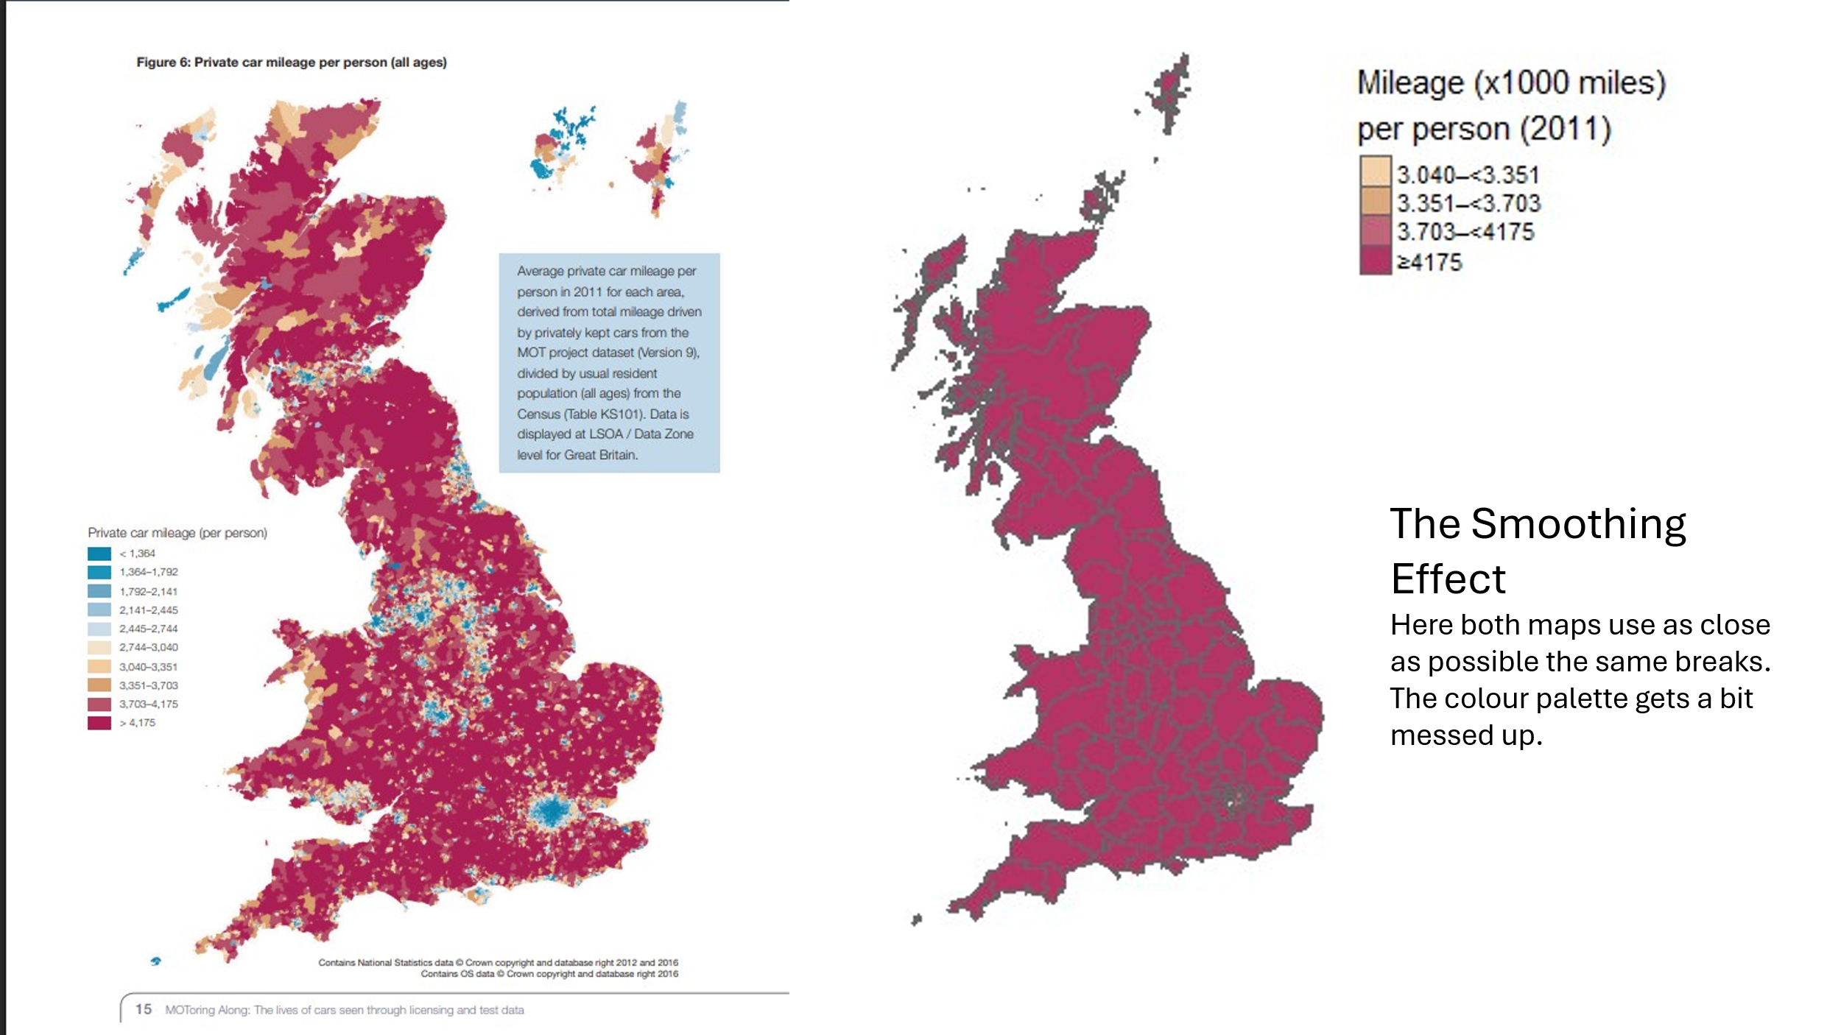

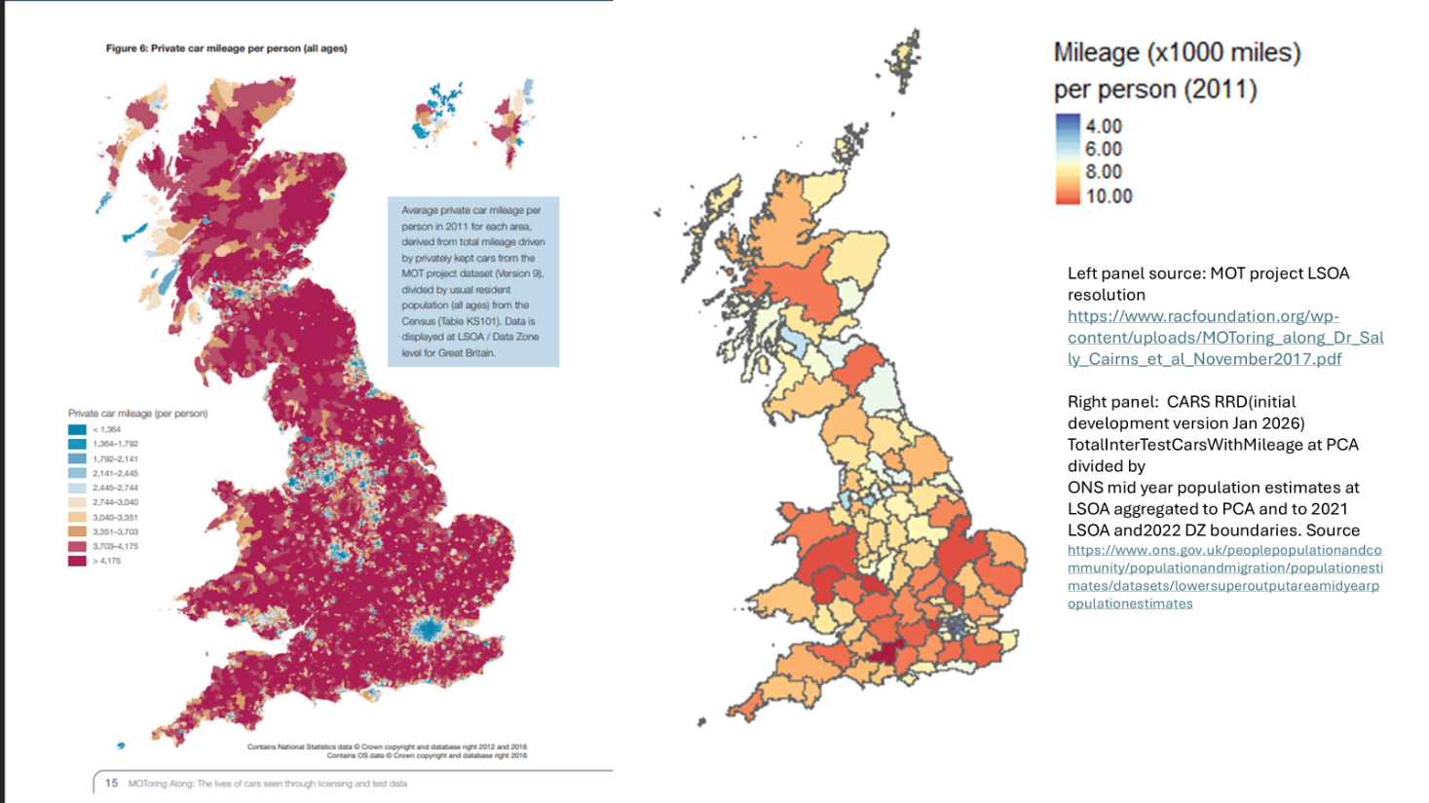

The PCA resolution data captures low mileage in London and the metropolitan cities - when we choose the breaks
If we keep the same breaks as the LSOA MOToring along it gives some insight into the smoothing effect. Low mileage city core areas are lost when aggregated with higher mileage hinterland areas.
We could quantify the amount of smoothing. E.g. Take the MOT LSOA data and calculate variance at LSOA and PCA resolution and check the difference.

TODO add info about other analysis to understand smoothing e.g. I looked at variance reduction

Spatial auto correlation

Spatial auto-correlation is a tool sometimes used to see if large aggregate areas are telling us something useful about regions. [REF NEEDED ] . If there were groups of neighbouring PCAs with similar values of miles pp, this can be indication that the signal is genuine and not noise.

An example is given below :
TODO
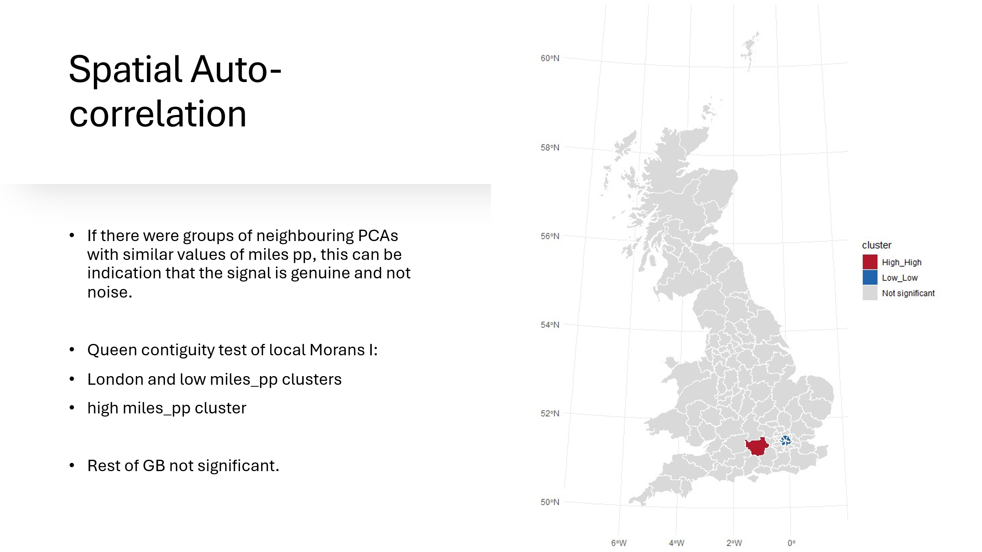



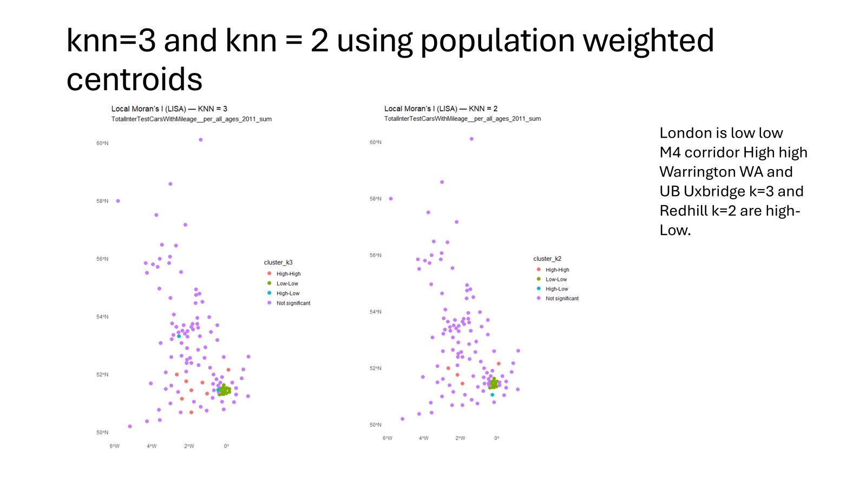

Both approaches to spatial auto-correlation show that there is some but limited evidence of groups of PCAs having similar mileage rates. However the most prominent cluster is the “low low” cluster of London boroughs. This is not an insightful finding – it is well known that there car use by Londoners is lower than the rest of the country. One could argue it suggests some validity if the data. This is true, however it is only valid in that it determines that London car use is lower than almost all of the rest of the country , which is not insightful.

Methodology
This chapter outlines the methodology for creating the research ready datasets. It explains the underlying assumptions and cleaning process to convert administrative data into research ready data.

Data Sources

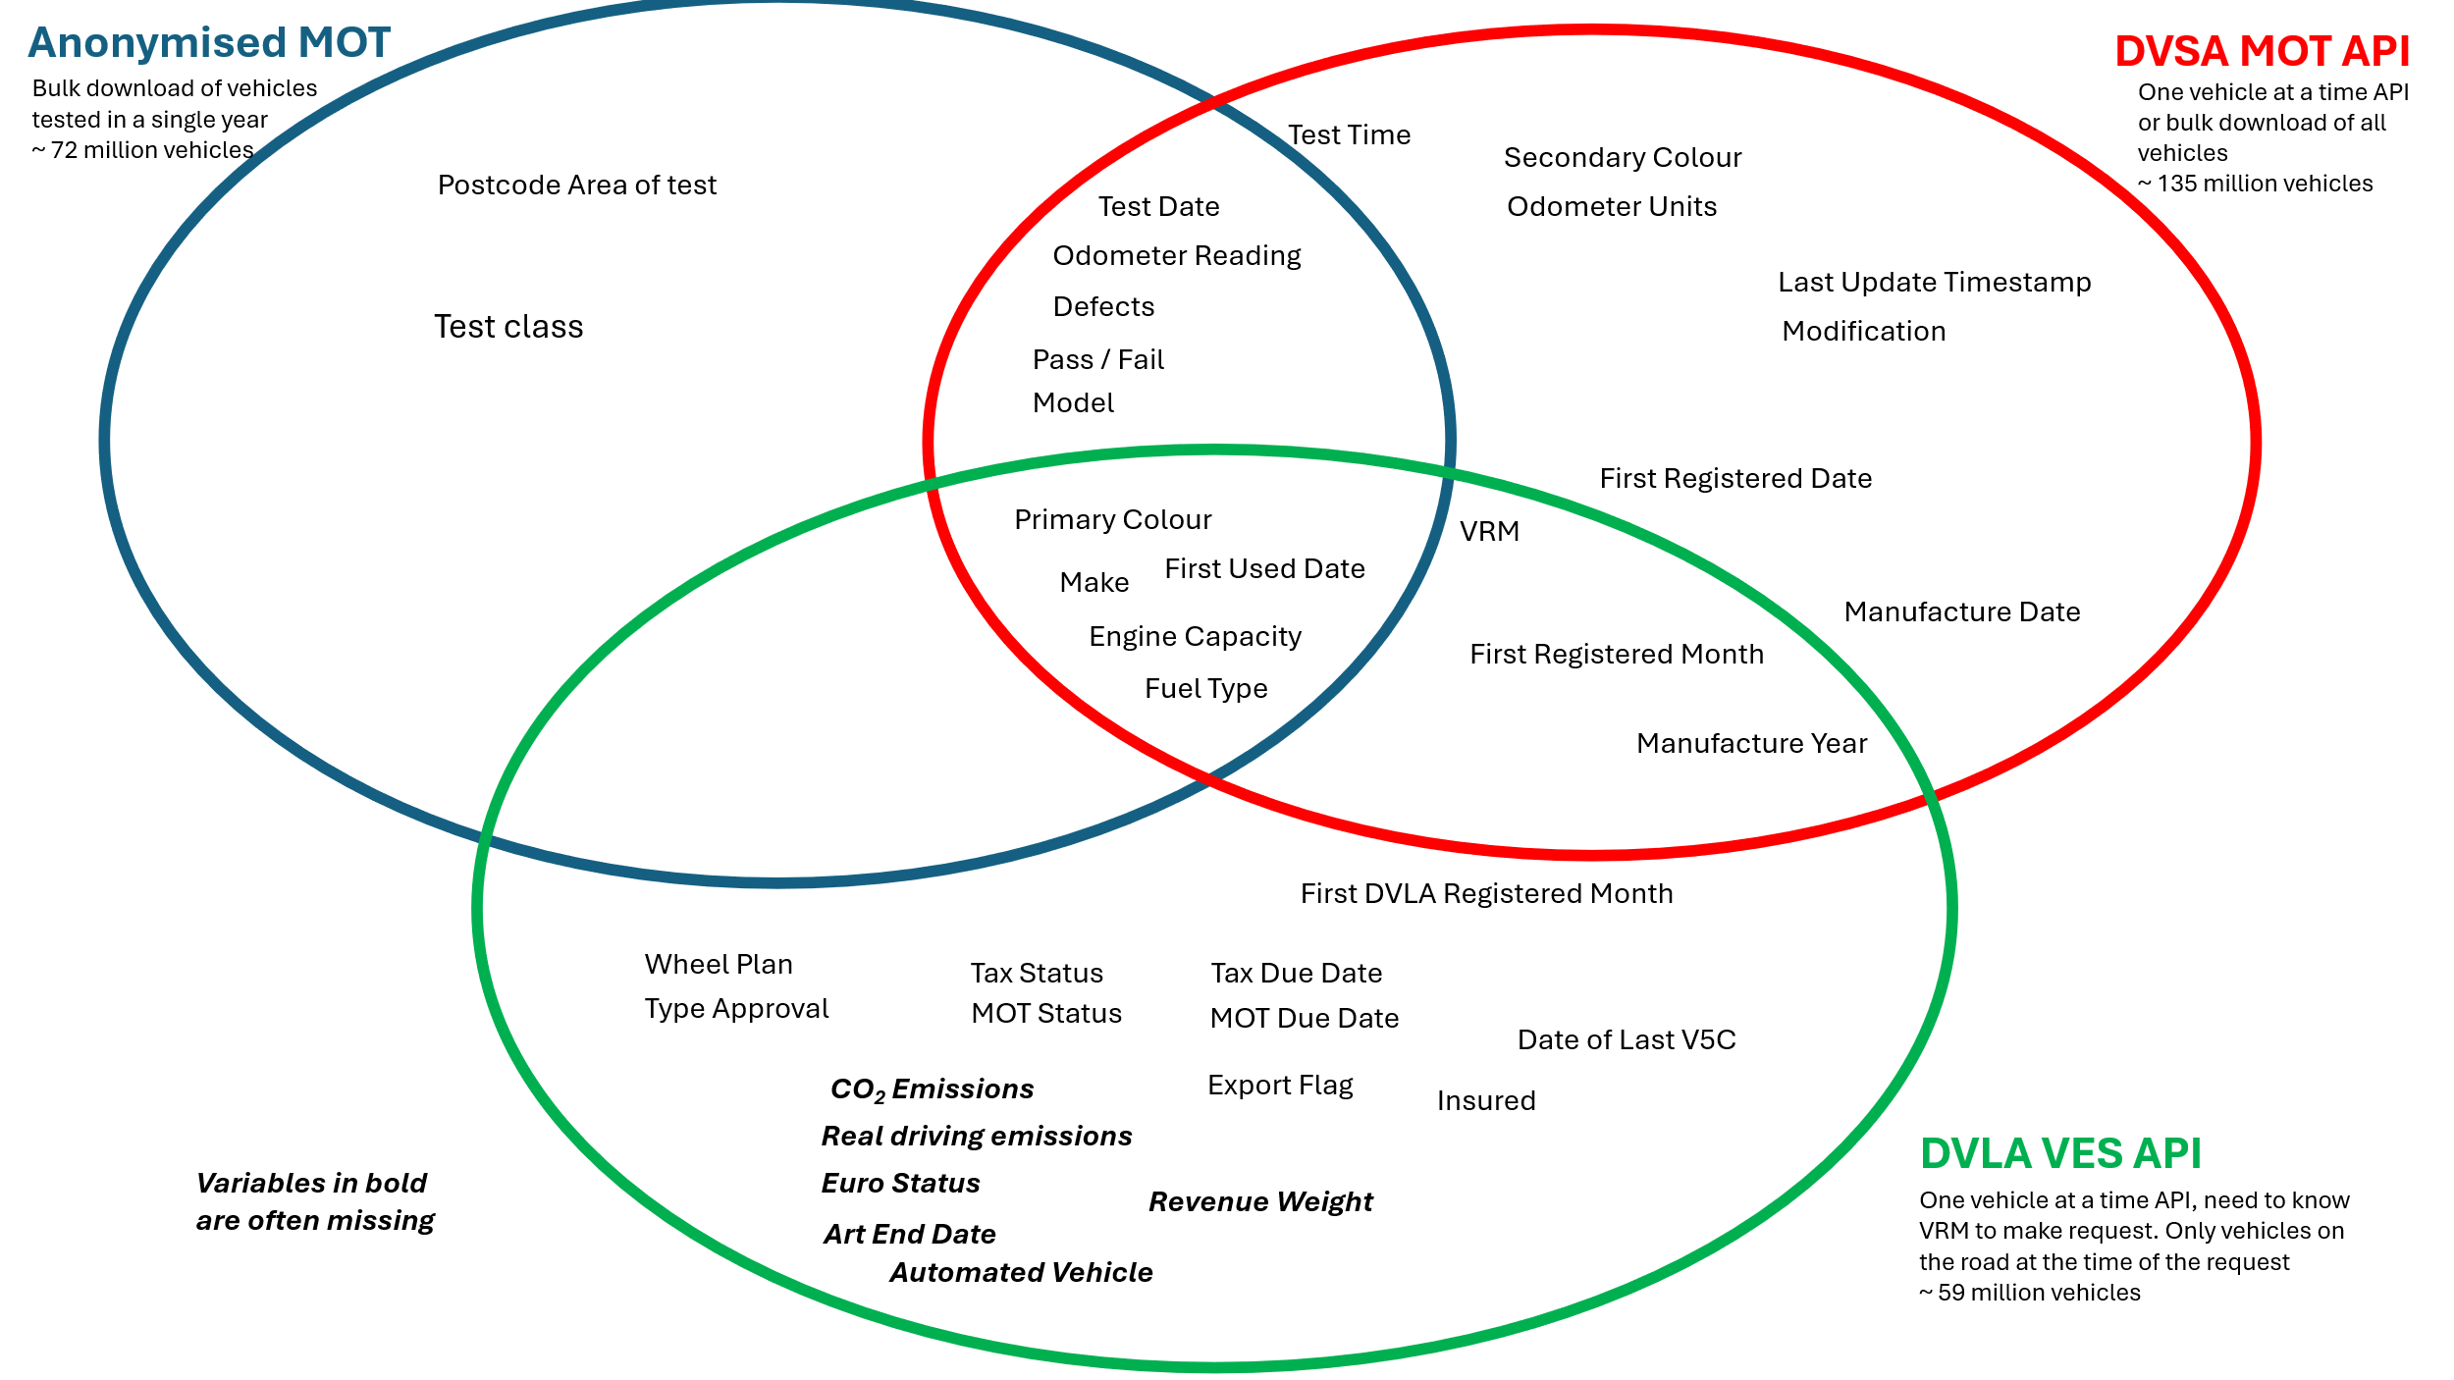

Figure: A diagram illustrating the fields in each OGL data source.

We are using data sources which are freely and openly available under Open Government Licences (OGL). As such, under the terms of this licence we are free to manipulate, summarise, reconfigure and republish the information contained within the data sources. There are no costs to accessing this data. Because the data licence allows onward republishing then this data is not personal or confidential – the government has deemed it appropriate to make open data. However, we note that the anonymous release of MOT data contains Vehicle Registration Mark (usually known as number plate); in some instances this can be deemed personal data. The details of the data sources, which we will combine in order to make research ready data, are as follows:

The anonymous release of MOT data All vehicles in GB over 3 years old have an annual roadworthiness test (MOT test). An anonymised version of the test result data is published approximately annually (initially by the DfT in 2010 (with vehicles now spanning 2005-2023), most recently by the DVSA (2022-2024). In recent years, over 40 million tests have been carried out and added to the data each year. Although this is open data (OGL license) it is not research-ready: both its structure and extreme size present barriers to its use (except by specialist data scientists).

DVSA Bulk data API : The Driver and Vehicle Standards agency is an agency of the UK government’s Department for Transport. This dataset is also published under OGL but requires an application process for an API key: https://documentation.history.mot.api.gov.uk/mot-history-api/download-vehicle-mot-history-data/files/
It includes all registered vehicles and their MOT history, even those that have not taken a test yet. Some additional vehicle characteristics are also included. There is, however, no locational data included. Data can be downloaded in bulk as a series of zipped JSON files. Due to their size (>400 GB) and structure, they can only realistically be handled by specialist data scientist. This data can be linked with Anonymised MOT data by the series of MOT test dates and odometer readings to produce a unique ‘fingerprint’ for each vehicle. This will allow each vehicle in our restructured MOT ‘vehicle centric’ dataset to be appended with the Postcode area of the MOT test location

DVLA Vehicle Enquiry Service data: This is a dataset available from the Driver Vehicle Licencing Agency (DVLA). The DVLA is an agency of the UK government’s Department for Transport. It is also released under OGL. It is accessed through an API. https://developer-portal.driver-vehicle-licensing.api.gov.uk/index.html
It is to be noted that as all three datasets have been published under the OGL the joining of these datasets is allowed under the terms of the OGL.
However, if during our production of RRD (Research-Ready-Dataset) we discover mechanisms that would allow re-identification of individuals then we will 1) make the data owners aware 2) ensure our data is stored in a suitable location for the level of sensitivity discovered. 3) We would arrange for the RRD and associated code to be made available at the appropriate level of safeguarding (following the tiered approach to access used by the UK data service).
Github repositories will be private during the development phase so if potential disclosiveness is discovered exploits are not freely available as code.

DVSA Bulk MOT API

DVSA Bulk data API : The Driver and Vehicle Standards agency is an agency of the UK government’s Department for Transport. This dataset is also published under OGL but requires an application process for an API key: https://documentation.history.mot.api.gov.uk/mot-history-api/download-vehicle-mot-history-data/files/
It includes all registered vehicles and their MOT history, even those that have not taken a test yet. Some additional vehicle characteristics are also included. There is, however, no locational data included. Data can be downloaded in bulk as a series of zipped JSON files. Due to their size (>400 GB) and structure, they can only realistically be handled by specialist data scientist. This data can be linked with Anonymised MOT data by the series of MOT test dates and odometer readings to produce a unique ‘fingerprint’ for each vehicle. This will allow each vehicle in our restructured MOT ‘vehicle centric’ dataset to be appended with the Postcode area of the MOT test location

Anonymised MOT Data
The anonymous release of MOT data All vehicles in GB over 3 years old have an annual roadworthiness test (MOT test). An anonymised version of the test result data is published approximately annually (initially by the DfT in 2010 (with vehicles now spanning 2005-2023), most recently by the DVSA (2022-2024). In recent years, over 40 million tests have been carried out and added to the data each year. Although this is open data (OGL license) it is not research-ready: both its structure and extreme size present barriers to its use (except by specialist data scientists).

DVLA Vehicle Enquiry Service (VES) API
DVLA Vehicle Enquiry Service data: This is a dataset available from the Driver Vehicle Licencing Agency (DVLA). The DVLA is an agency of the UK government’s Department for Transport. It is also released under OGL. It is accessed through an API. https://developer-portal.driver-vehicle-licensing.api.gov.uk/index.html
It is to be noted that as all three datasets have been published under the OGL the joining of these datasets is allowed under the terms of the OGL.
However, if during our production of RRD (Research-Ready-Dataset) we discover mechanisms that would allow re-identification of individuals then we will 1) make the data owners aware 2) ensure our data is stored in a suitable location for the level of sensitivity discovered. 3) We would arrange for the RRD and associated code to be made available at the appropriate level of safeguarding (following the tiered approach to access used by the UK data service).

Linking the Anonymised MOT to the Bulk MOT data

Linking the VES API to the Bulk MOT data

TODO: Wills flow charts and slides from meeting on 23/06/2026 as basis for methodology of joining VES api data to the DVSA spine

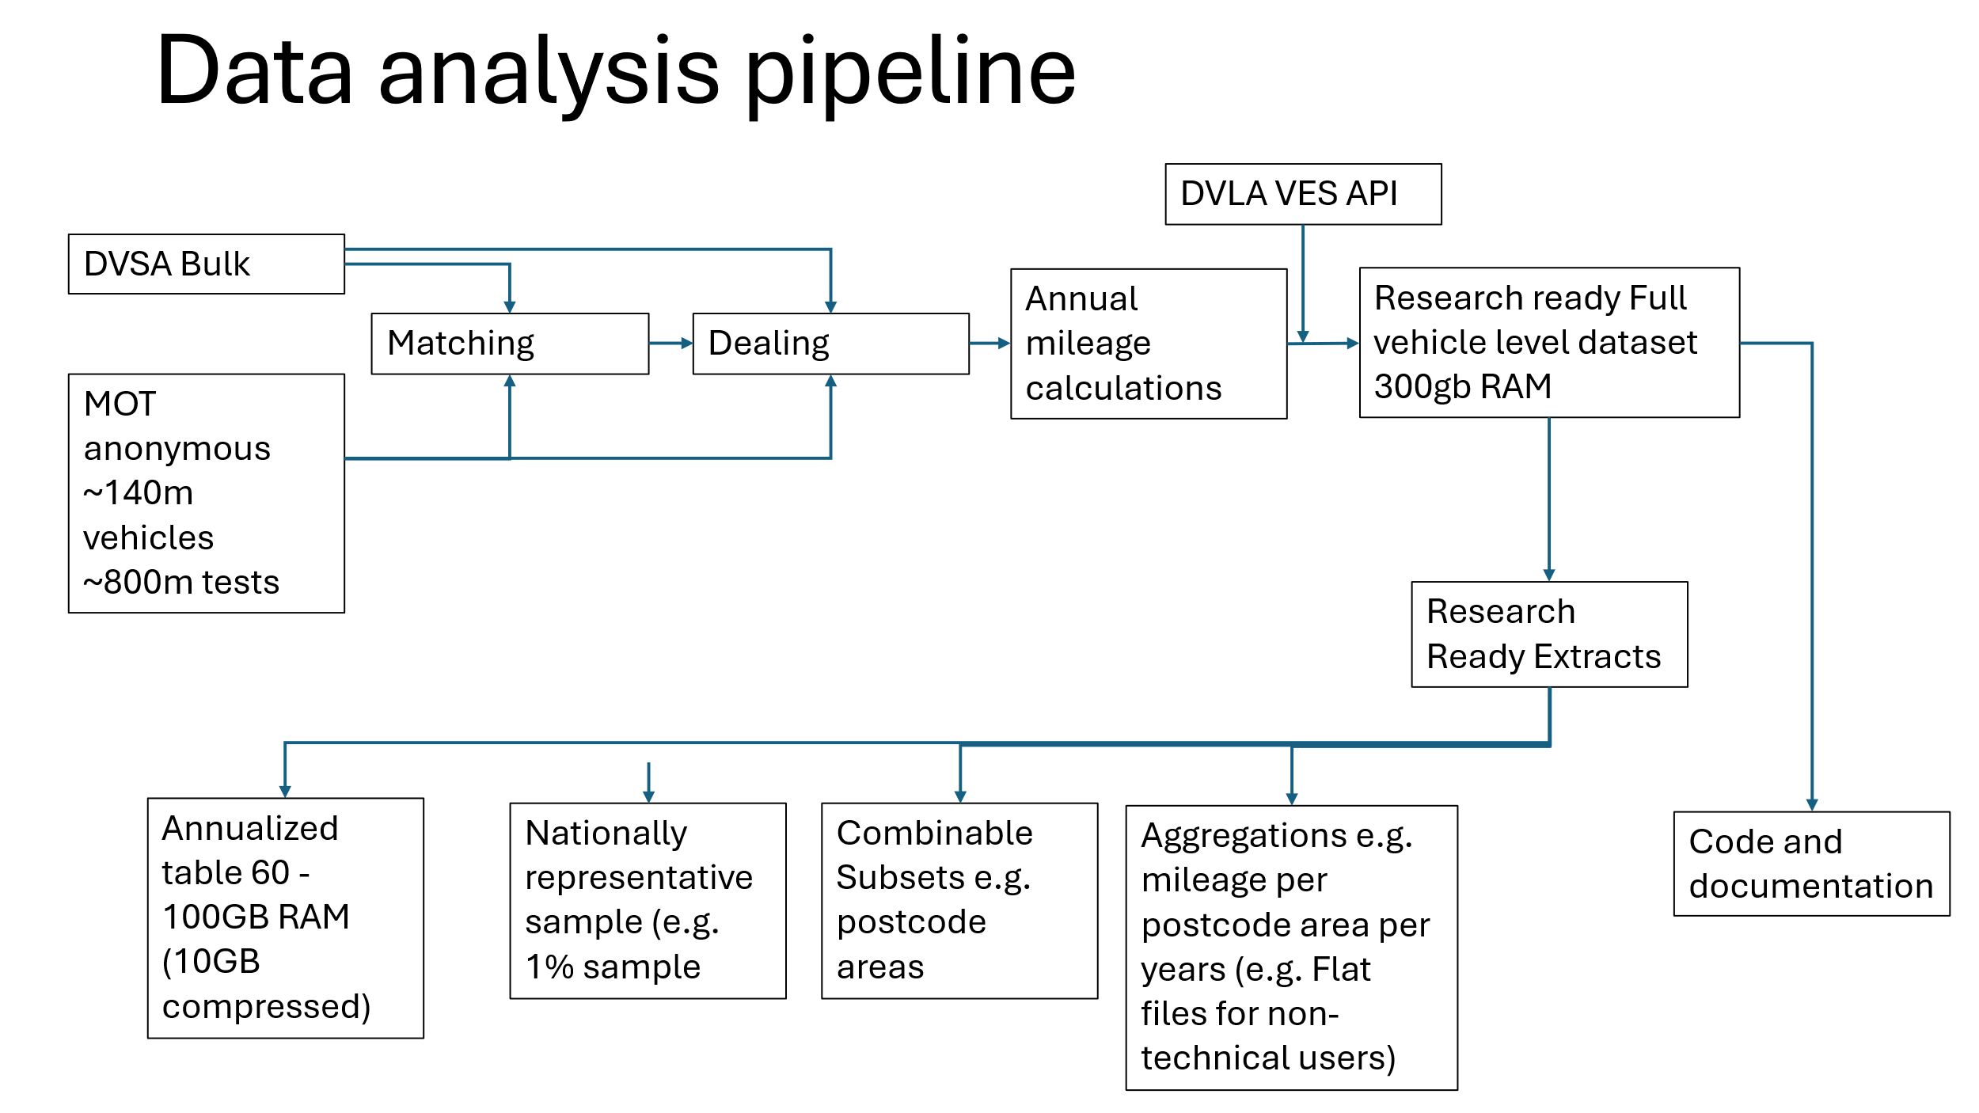

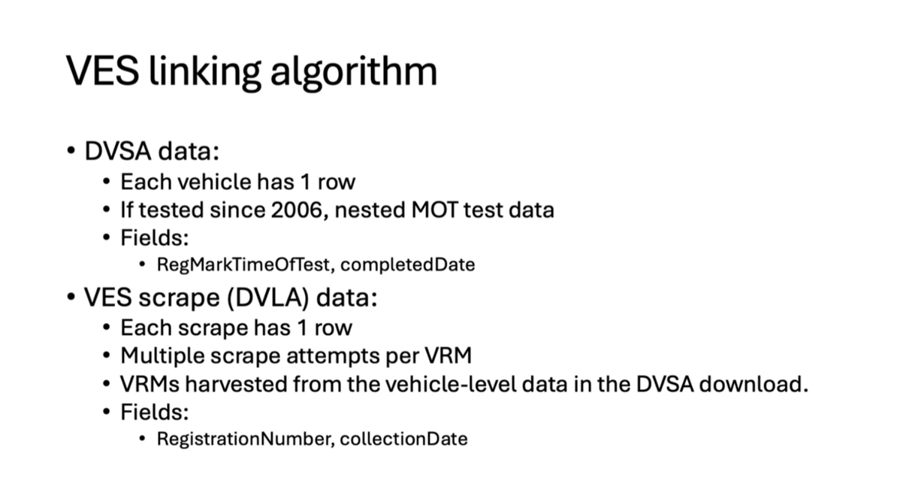

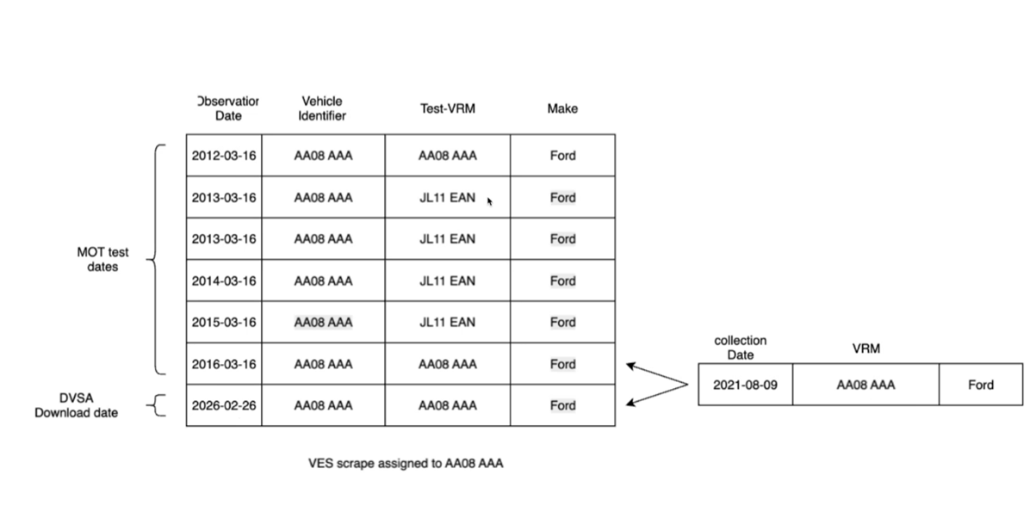

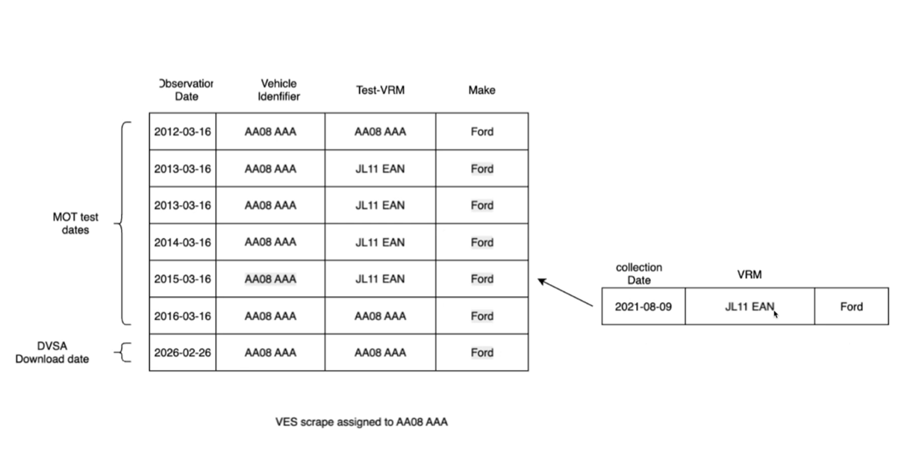

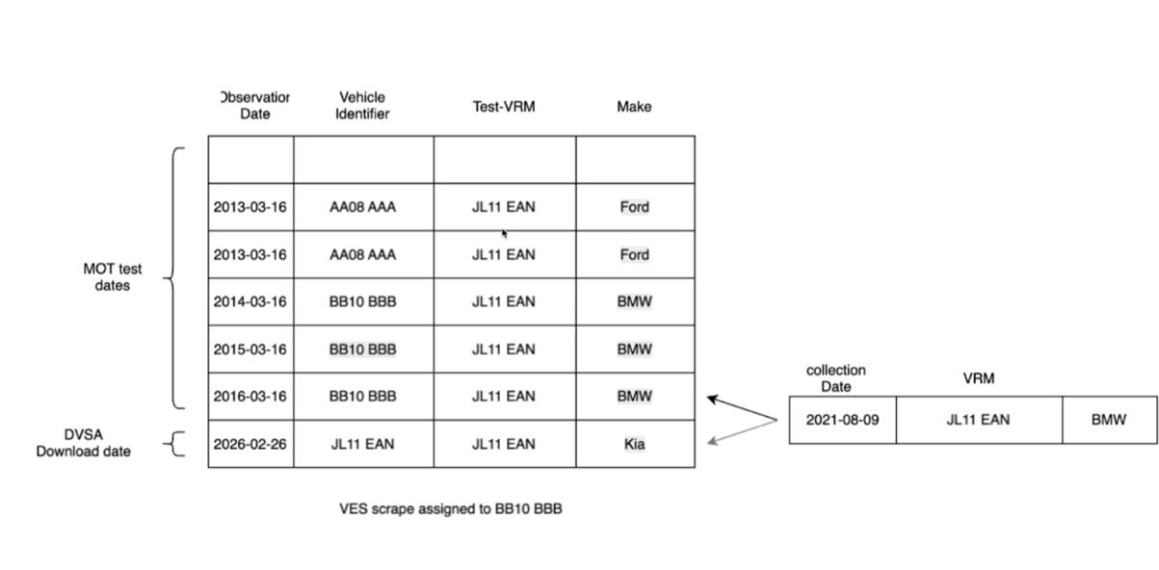

How data was scraped from the VES API .
TODO : Malcolm to explain these categories.
Have data from VES API
Has invalid VRM - will never get data
Has invalid VRM - have proposed cleaned version with data
Vehicle not found - assumed died a long time ago
Vehicle not found - but have data in at some point
Never checked against VES API

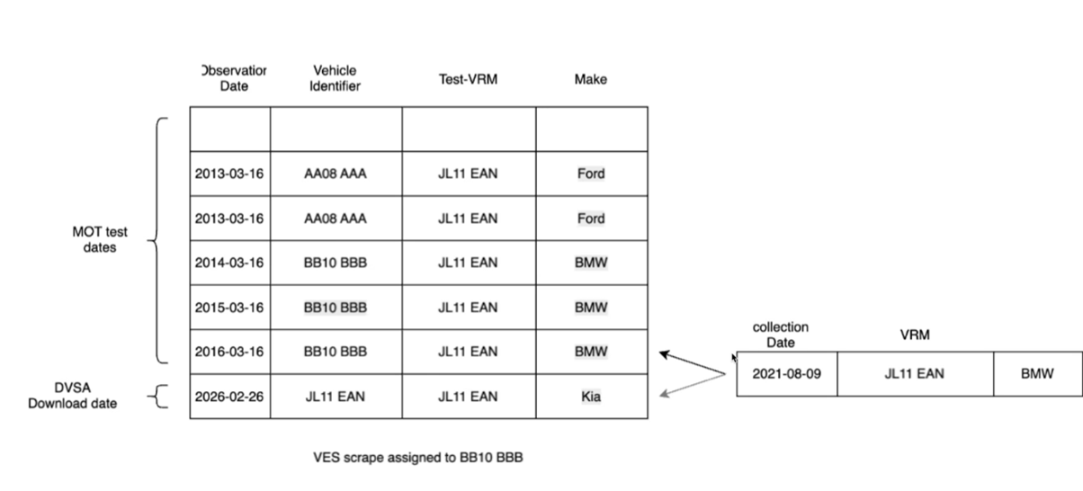

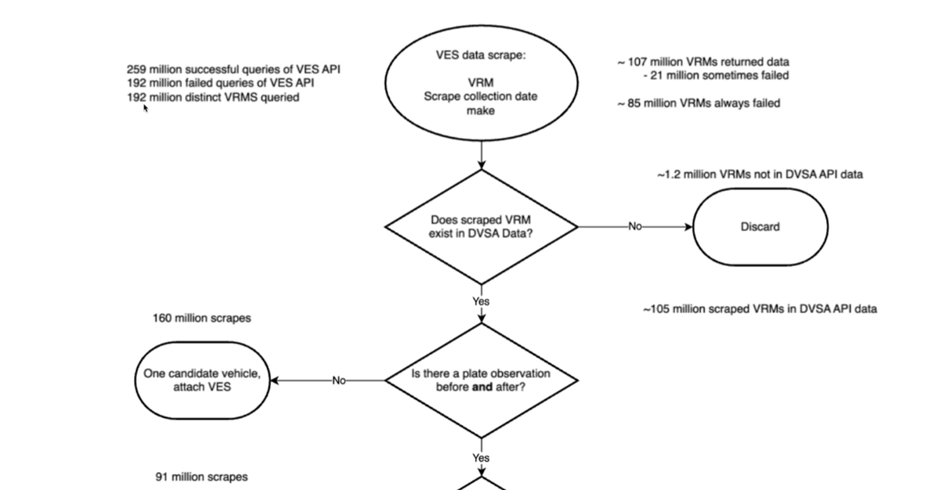

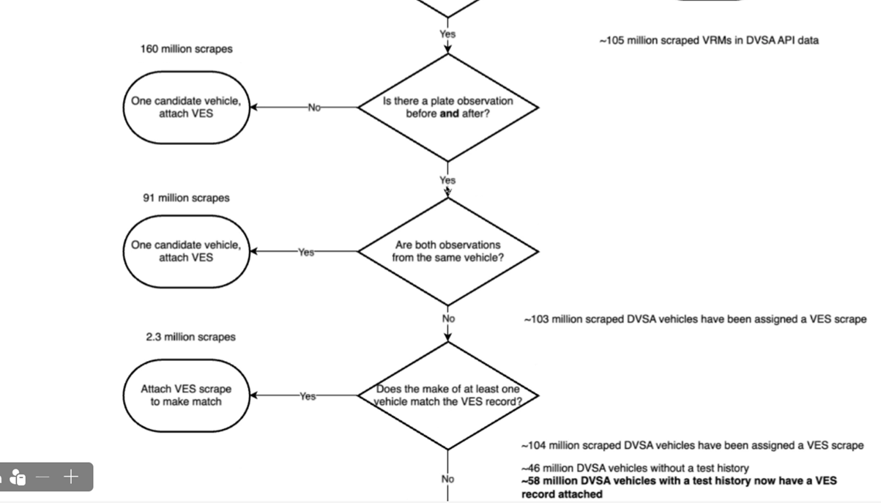

Make and Model Cleaning

VRM Analysis

Annual Milage Calculation

Determining test intervals for mileage calculation

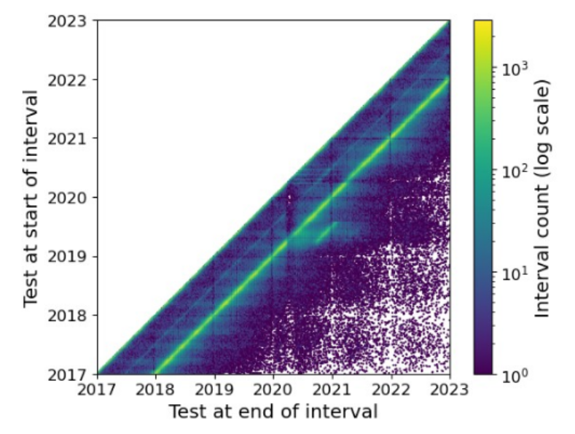

Mileage band analysis
Based on table NTS0904, and email on 26/6/26 - key graphs:
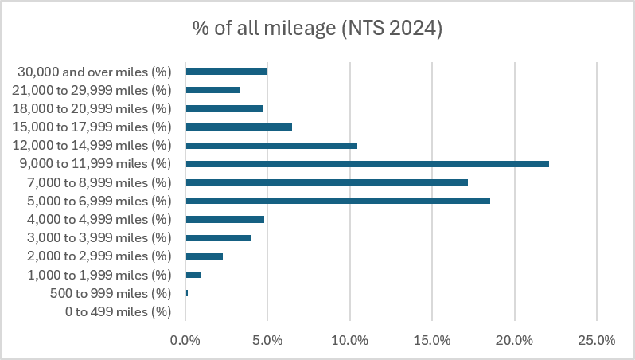
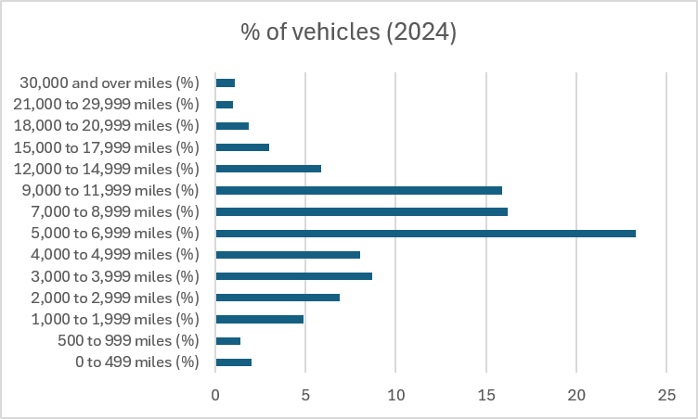

Key Concepts

MOT test classes and vehicle types

Table 1: MOT Test Classes and requirements, from GOV.UK
 | Vehicle class | Age first MOT needed (years)
Motorcycle (engine size up to 200cc) | 1 | 3
Motorcycle with sidecar (engine size up to 200cc) | 1 | 3
Motorcycle (engine size over 200cc) | 2 | 3
Motorcycle with sidecar (engine size over 200cc) | 2 | 3
3-wheeled vehicles (up to 450kg unladen weight) | 3 | 3
3-wheeled vehicles (over 450kg unladen weight) | 4 | 3
Cars (up to 8 passenger seats) | 4 | 3
Motor caravans | 4 | 3
Quads (max unladen weight 400kg - for goods vehicles 550kg and max net power of 15kw) | 4 | 3
Dual purpose vehicles | 4 | 3
Private hire and public service vehicles (up to 8 seats) | 4 | 3
Ambulances and taxis | 4 | 1
Private passenger vehicles and ambulances (9 to 12 passenger seats) | 4 | 1
Goods vehicles (up to 3,000kg design gross weight) | 4 | 3
Class 4 vehicles (9 to 12 passenger seats) with a seat belt installation check | 4a | n/a
Private passenger vehicles and ambulances (13 to 16 passenger seats) | 5 | 1
Private passenger vehicles and ambulances (more than 16 passenger seats) | 5 | 1
Playbuses | 5 | 1
Class 5 vehicles (13 to 16 passenger seats) with a seatbelt installation check | 5a | n/a
Class 5 vehicles (more than 16 passenger seats) with a seatbelt installation check | 5a | n/a
Goods vehicles (over 3,000kg up to 3,500kg design gross weight) | 7 | 3

Differences between type approval, DfT stats and MOT stats
Different body types fall under different regulatory categories. For example:
- Passenger cars (M1) have requirements for occupant protection, emissions, braking, lighting, etc.
- Goods vehicles (N1/N2) have different braking, stability, and loading requirements.
- Specialist vehicles (motor caravans, ambulances, hearses) may have exemptions or additional tests.
The body type helps determine which category the vehicle belongs to, and therefore which standards must be met. This is reflected in the technical guidance for GB Type Approval.
M-category — Passenger vehicles
These cover vehicles designed primarily for carrying people.
- M1 — Passenger cars with up to 8 passenger seats (excluding driver).
- M2 — Passenger vehicles with more than 8 seats and ≤ 5 tonnes maximum mass.
- M3 — Passenger vehicles with more than 8 seats and > 5 tonnes maximum mass.
These categories include sub-types such as saloons, hatchbacks, MPVs, minibuses, and full-size buses.
N-category — Goods vehicles
These cover vehicles designed for carrying goods.
- N1 — Goods vehicles ≤ 3.5 tonnes (e.g., vans, pickups).
- N2 — Goods vehicles > 3.5 tonnes and ≤ 12 tonnes.
- N3 — Goods vehicles > 12 tonnes.
These categories determine requirements for load security, braking, stability, emissions, and more.
The MOT system is separate from type approval, and the MOT uses its own MOT Classes (Class 1–7). The link between the two is that a vehicle’s type-approval category (M, N, L, O) determines what kind of vehicle it is, and that determines which MOT class applies.
M-category (Passenger vehicles) → MOT Classes 3, 4, 5, 7
These vehicles all require MOT tests once over 3 years old.
- M1 (cars, SUVs, MPVs) → Class 4 MOT
- M2 (minibuses ≤ 5 tonnes) → Class 4 or 5 MOT depending on seating
- M3 (buses > 5 tonnes) → Class 5 MOT
The MOT inspection manual for cars and passenger vehicles explicitly covers Classes 3, 4, 5 and 7.
N-category (Goods vehicles) → MOT Classes 4 or 7
Goods vehicles also require MOT tests, but the class depends on weight.
- N1 (vans and pickups ≤ 3.5 tonnes) → Class 4 or Class 7 MOT
- N2/N3 (HGVs > 3.5 tonnes) → HGV annual test, not a standard MOT
So: ✔ N1 = standard MOT ✘ N2/N3 = separate HGV test regim
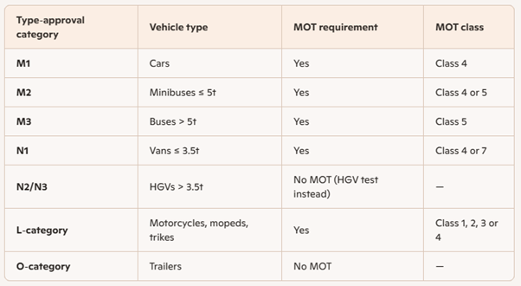
M2 vehicles (minibuses up to 5 tonnes)
M2 vehicles can fall into Class 4 or Class 5, depending on number of passenger seats.
A Class 4 MOT applies when:
- the vehicle has up to 12 passenger seats (excluding the driver), and
- its maximum weight is no more than 5 tonnes.
A Class 5 MOT applies when:
- the vehicle has more than 12 passenger seats.
So for M2, seat count is the decisive factor.
N1 vehicles (goods vehicles up to 3.5 tonnes)
N1 vehicles can fall into Class 4 or Class 7, depending on design gross weight.
A Class 4 MOT applies when:
- the vehicle’s design gross weight is 3,000 kg or less.
A Class 7 MOT applies when:
- the vehicle’s design gross weight is over 3,000 kg and up to 3,500 kg.
This distinction is widely used in MOT classification tools and guidance, which note that vans and light commercial vehicles may be Class 4 or 7 depending on weight
[compared to road traffic stats definition of cars and vans] class 4 does NOT include vans >3kg up to 3.5kg, and DOES include vehicles with 10-12 seats weighing up to 5 tonnes. Type approval doesn’t seem to differentiate taxis.
Road traffic stats definitions used:
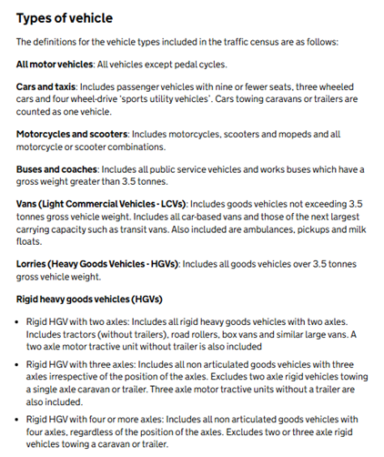

The ‘Lifecycle’ of a vehicle

Newly built vehicles

Vehicles imported into the UK

The first MOT test

Jillian and sally want to know if there is a flag that shows if a vehicle has had its first test before 3 years ?

Subsequent MOT tests

Statutory Off Road Notice (SORN)ed vehicles

You need to make a SORN (Statutory Off Road Notification) when you take a vehicle ‘off the road’ and you want to stop taxing and insuring it. (https://www.gov.uk/sorn-statutory-off-road-notification)

When an application is made to SORN a vehicle it does not have to be renewed. If the vehicle is taxed then the vehicle SORN is automatically ended.

TODO : There was a period when SORN was not indefinite . give details .
Possible sources https://www.gov.uk/government/news/dvla-busts-9-myths-around-sorn-statutory-off-road-notification

And https://www.legislation.gov.uk/ukia/2013/188/pdfs/ukia_20130188_en.pdf

End of life vehicles

Data Products

Full Data Set

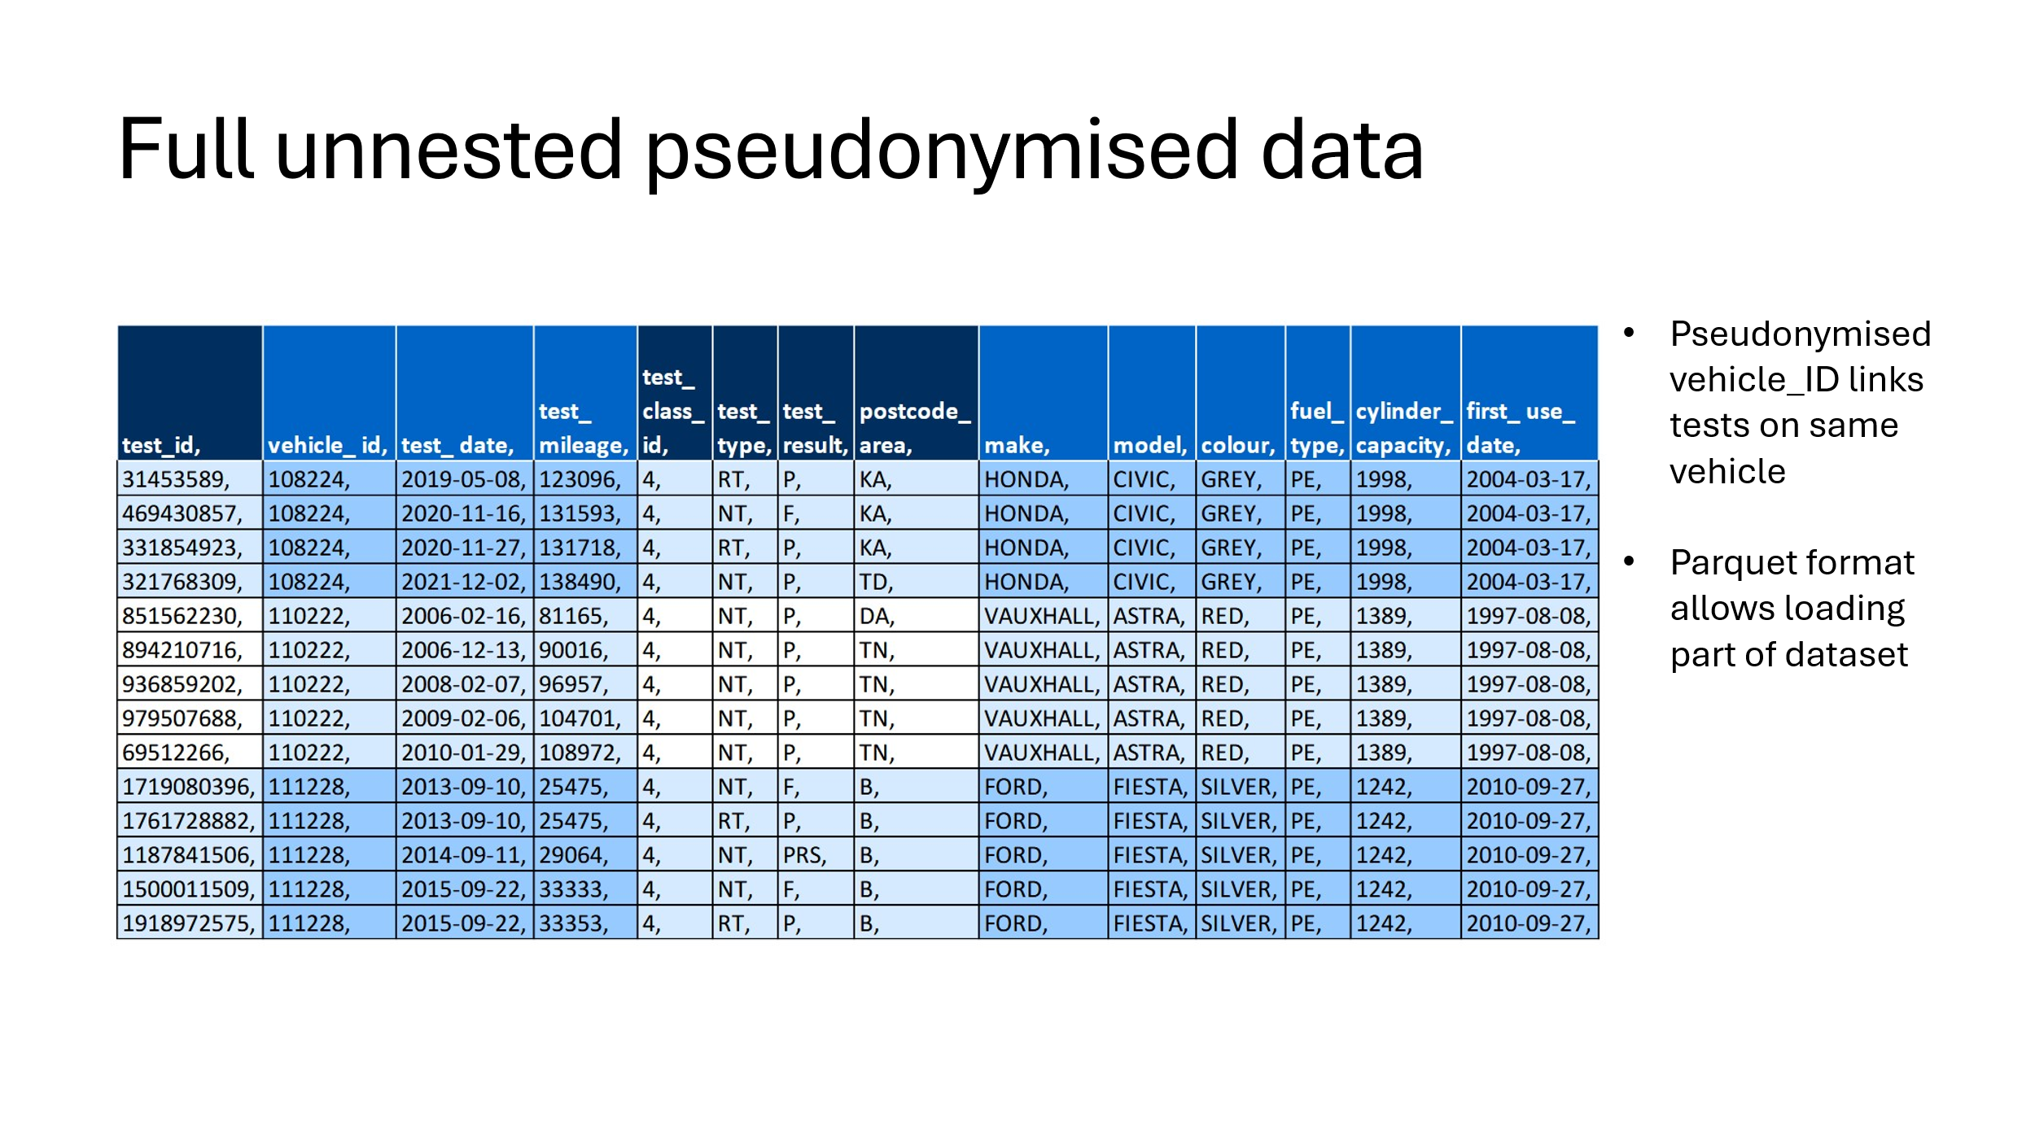

Licensing, Access, and conditions of use

Annulised Table

Is_intertest
Email from Will

The field is_intertest is FALSE in the first use period and FALSE in the end use period, and TRUE if the straddle date - 01-July in a year - has a test on each side.

The field is set to NULL if the time between the tests either side of the straddle date is more than 2 years, or the car hasn’t yet been born, or it’s been over a year since the final test on record.

This vehicle has a first use date of 01-Sep-2007, but it’s first test on record is 2013. After that it has tests in 2014, 2016, 2018, 2020, 2021, 2022, 2023 and 2024. It is missing tests for 2015, 2017 and 2019.

It managed to go 6 years without an MOT test.

There was a 26 month gap between the 2016 test and the 2018 test. This is too long, so the field is set to null.

Between the 2018 test and the 2020 test there is a smaller gap - 23 months which is under the 2 year threshold, so is_intertest is TRUE.

An unborn vehicle - where the 01st July that year is before the registration date or first use date - will have NULL for all is_something fields.

A vehicle that has permanently ceased operations - the 01st July is more than 1 year since the final mot test on record - will also be NULL for the is_something fields.

The mileage calculations and PCA attribution doesn’t take the time to the preceding or following tests into account. A mileage exists if there are odometer readings available to use and has is_legit_mileage as TRUE if the miles per day aren’t nonsense. A PCA is attributed in a year using the closest test for which we have a PCA available.

So ‘unborn’ vehicles are those where the firstUsedDate or registration date after the 1st of July in a year, and ‘dead’ vehicles are those who haven’t had a test since 1st of July the previous year.

Unborn vehicles will be null for all binary flags, but not in later years. Dead vehicles will be null for all binary flags but not in later years.

Even though an intertest period might be long and set is_intertest to NULL, the miles driven between tests will still be distributed across all years.

Malcolm Table
Malcolm’s post processed version of the data from Will

Variable Level Descriptions
Variable | Description
registration_DVLA
registration_DVSA
make_DVSA
make_DVLA_main
model_DVSA
fuel_DVSA
fuelType_DVLA
engineSize_DVSA
engineCapacity_DVLA
primaryColour_DVSA
secondaryColour_DVSA
colour_DVLA
typeApproval_DVLA
revenueWeight_DVLA
wheelplan_DVLA
test_class_ANON
co2Emissions_DVLA
euroStatus_DVLA
realDrivingEmissions_DVLA
automatedVehicle_DVLA
markedForExport_DVLA
taxStatus_DVLA
taxDueDate_DVLA
motStatus_DVLA
birthDate
collectionDate
lastMotTestDate_DVSA
dateOfLastV5CIssued_DVLA
motExpiryDate_DVLA
monthOfFirstRegistration_DVLA
monthOfFirstDvlaRegistration_DVLA
yearOfManufacture_DVLA
artEndDate_DVLA
n_api_vehicles_with_vrm
vrm_in_ves
n_ves_obs
mileage_2005 to mileage_2024
pca_2005 to pca_2024
registration_DVSA_cleaned
plateType
plateDate
plateLocation

Anonymised Vehicle Level Data

Licensing, Access, and conditions of use

Aggregated Data

Licensing, Access, and conditions of use
This data is provided as open data.

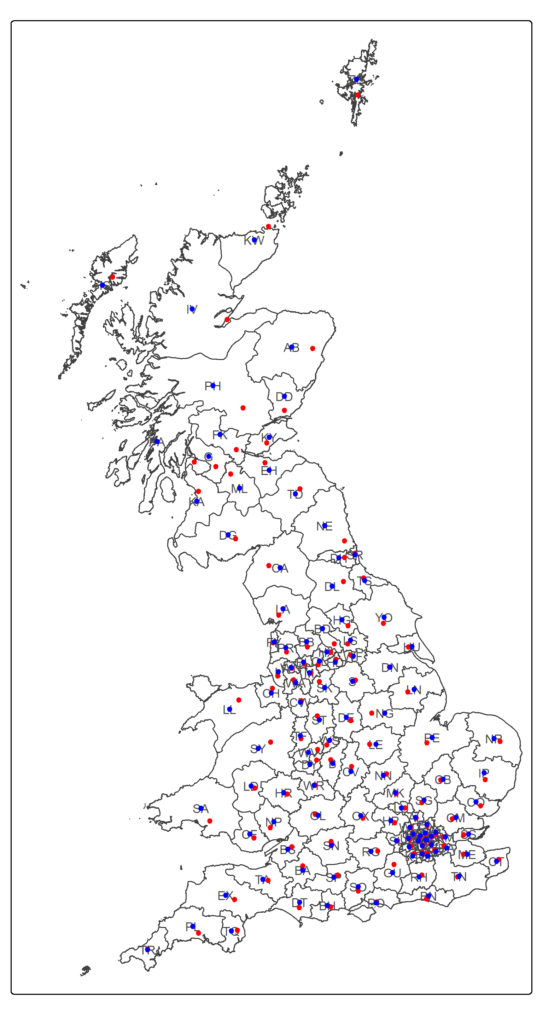
Spatial resolution of aggregated data. Note that vehicles which cannot be assigned a location are included but labelled “unknown”

Example Analysis

References
Bournemouth University, 2005, Citing References, www.bournemouth.ac.uk/academic_services/documents/Library/Citing_References.pdf. [Accessed August 2006].

Appendices
Appendix 1 Data Dictionary for Anonymized Vehicle Level Data 11
Appendix 2 12

Appendix 1 Data Dictionary for Anonymized Vehicle Level Data
Variable Name | Data Type | Source | Description
registration_DVSA | String | DVSA Bulk API
make_DVSA | String | DVSA Bulk API
model_DVSA | String | DVSA Bulk API
firstUsedDate_DVSA | Date | DVSA Bulk API
registrationDate_DVSA | Date | DVSA Bulk API
manufactureDate_DVSA | Date | DVSA Bulk API
primaryColour_DVSA | String | DVSA Bulk API
secondaryColour_DVSA | String | DVSA Bulk API
engineSize_DVSA | Integer | DVSA Bulk API
lastMotTestDate_DVSA | Date/Time | DVSA Bulk API
fuel_DVSA | String | DVSA Bulk API
test_class_anon | Integer | Anonymous MOT
mileage_20XX | Decimal | DVSA Bulk API (Derived)
pca_20XX | String | Anonymous MOT (Derived) | Postcode are of test
is_new_vehicle_20XX | Logical | DVSA Bulk API (Derived) | It is the vehicle in first three years of life. When MOT tests do not need to be performed
is_intertest_20XX | Logical | DVSA Bulk API (Derived) | Is there vehicle in the later period of its life > 3 years
is_end_use_20XX | Logical | DVSA Bulk API (Derived) | Is this the last year of the vehicles life?
legit_mileage_20XX | Logical | DVSA Bulk API (Derived) | Is the recorded milage legitimate (i.e. not negative or too large)

Appendix 2

